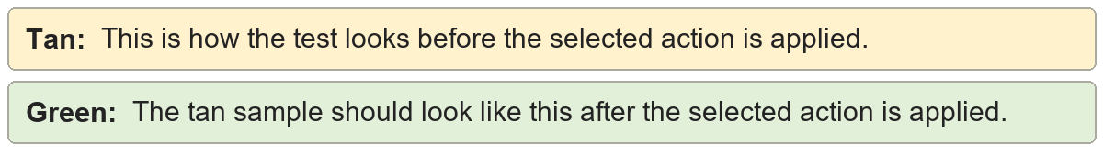
Hide hyperlink styling | Visit CleanupSuite documentation.
Hide hyperlink styling | Visit CleanupSuite documentation.

Remove hyperlinks | Open the CleanupSuite reference page.
Remove hyperlinks | Open the CleanupSuite reference page.

